**WRITING TASK 1**

You should spend about 20 minutes on this task

**The diagram below shows how orange juice is produced.**

Write at least 150 words.

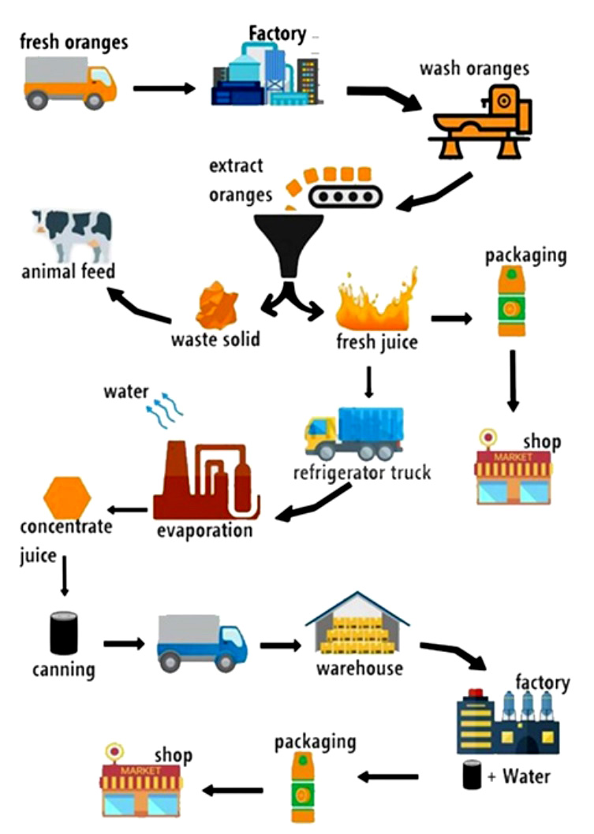

**WRITING TASK 2**

You should spend about 40 minutes on this task

Write about the following topic:

**Maintaining public libraries is a waste of money since computer technology can replace their functions. Do you agree or disagree?**

Give reasons for your answer and include any relevant examples from your own knowledge or experience.

Write at least 250 words.